1. **Event Binding:**

* Eg: If we have a button here and after two seconds this button is enabled
* It will be nice if we could do something, once we click the button.
* Lets add a new replication of our server component here.
* For now I want to output something. So I will remove the below line:

* Instead I will output the value of a property here. I will create the property: serverCreationStatus

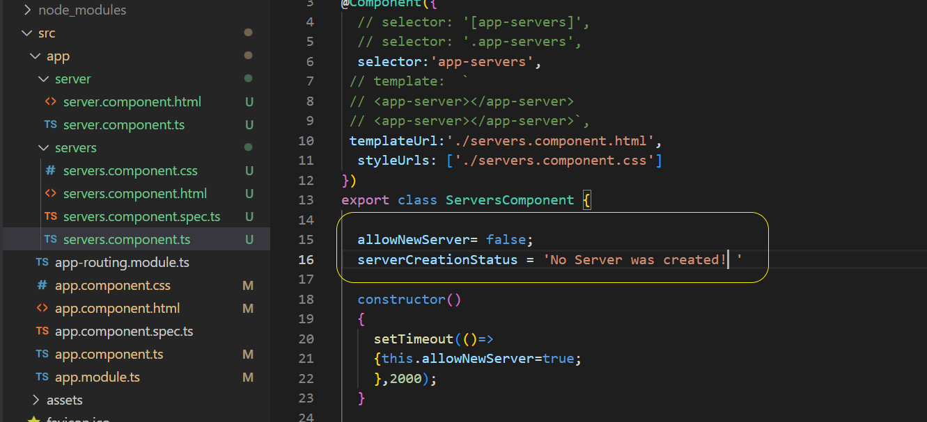

* Now lets output the same in html file using String interpolation

**Achieving Event Binding**

* But our motto now is not to output the string, but to listen to events. We will add another method in ServersComponent : onCreateServer()

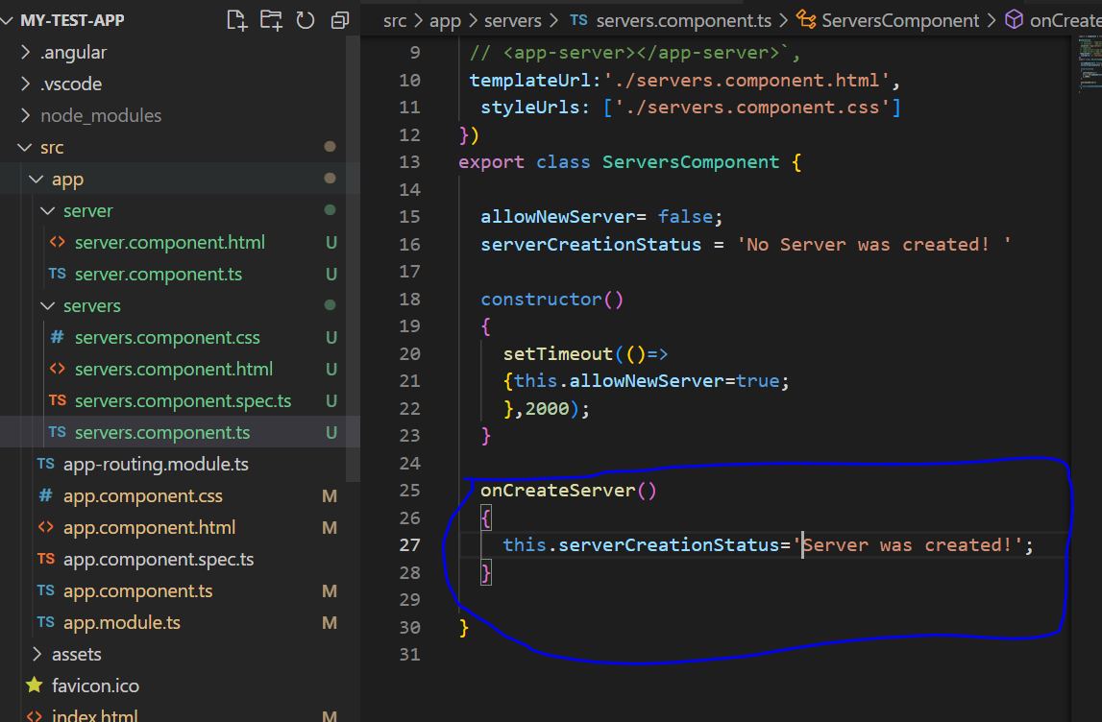

* Now is where eventBinding comes into play. We want to listen to click event here in servers.component.html ‘s button element.
* We have onClick attribute on the html element, where we can execute some java script code. But we wont use it here with Angular. Instead angular offers us Event binding.
* Event binding uses parenthesis, while property binding used square brackets.
* For events parenthesis are signals that we are going to use event binding.
* Name of the event should be specified in parenthesis eg: click
* We can bind to all the events made available by the html attribute, we are placing this on
* Hence if you have on click, on mouse enter, you could bind to click mouse enter, without the “on” at the beginning:

Eg: (click) = “”>Add Server</button>

* Now between quotation marks, we put the code which we want to execute when the event occurs.

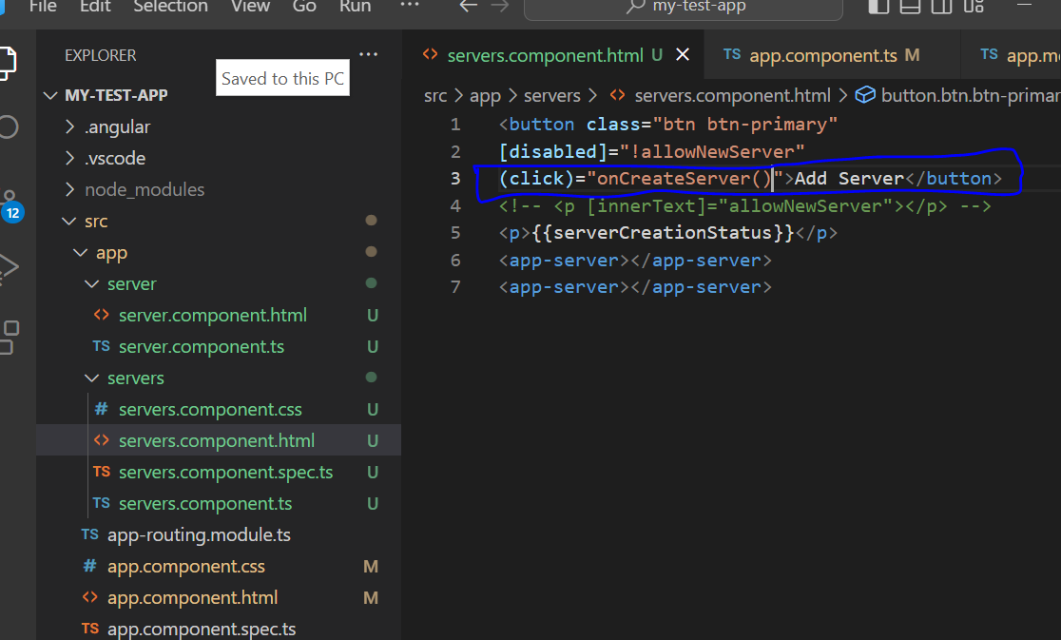

* In most scenarios, we will call a method here. So we will point to the method which we want to execute: In our case it is “onCreateServer()”
* So onCreateServer method will get executed whenever we click the button
* Thus we have binded the click event and we execute the onCreateServer() when it occurs
* We can observe the same in browser also.

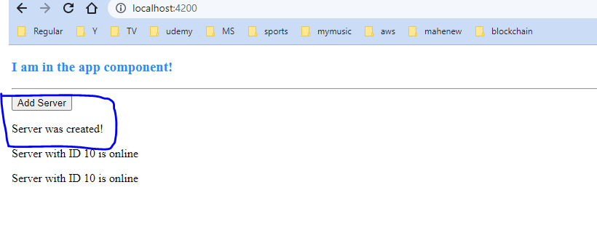

1. **Bindable Properties and Events**

* How do you know to which Properties or Events of HTML Elements you may bind? You can basically bind to all Properties and Events - a good idea is to console.log()  the element you're interested in to see which properties and events it offers.
* Important: For events, you don't bind to onclick but only to click (=> (click)).
* The MDN (Mozilla Developer Network) offers nice lists of all properties and events of the element you're interested in. Googling for YOUR_ELEMENT properties  or YOUR_ELEMENT events  should yield nice results.

1. **Passing and Using Data with Event Binding:**

* We need to know one important thing in Event Binding
* Lets say: we have a label and an input before the button in servers.component.html page

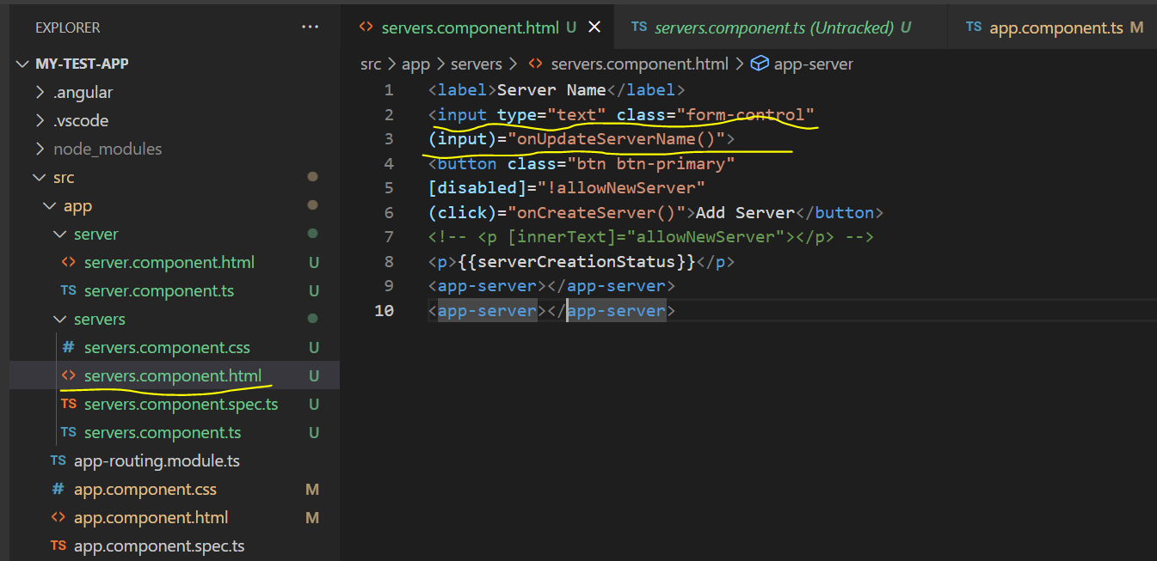

* So we add label and input element. The class is form-control for input
* Here we are listening to the input event . This is a normal DOM event provided by the input element. Here we listen to the onUpdateServerName(), because it will be fired on every key stroke.
* <input type="text" class="form-control"
* (input)="onUpdateServerName()">
* Now we add this method to the component in servers.component.ts file

**Dollar Sign event($event):Gives access to event data**

* Also I want to output whatever value what I entered . That can be done by adding $event to the function name passed in html file

Eg:

(input)="onUpdateServerName($event)">

* $event is a reserved variable name , we can use in the template while using event binding
* For the event: "onCreateServer()", dollar sign event ($event) will simply be the data emitted with that event.

**Some default events:**

* Input and click are default events provided by the dom. They give us some data when they are fired.
* The click events gives us the object: eg it holds the coordinates where we clicked.
* Input event gives us some information about the event

**Capturing data from Event:**

* We can capture the data returned by the event, using the dollar sign event($event) passed as an argument to the method we are calling or used anywhere between these quotation marks, in the code we are executing

**onUpdateServerName:**

* Here we pass the $event to onUpdateServerName. Here we know we will receive this event and this will be of type any for now
* Now lets simply log the event to the console, so that we can see it in the debug log

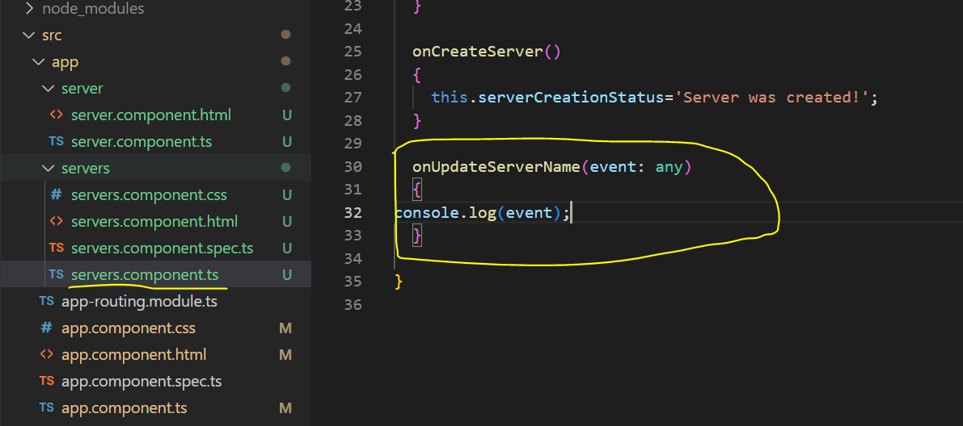

* Now if we check the same in browser, we can see in console that event data getting printed, for every entry in input

* Now if we check the console output, we can see there is target. Target is simply the html element on which this event occurred.

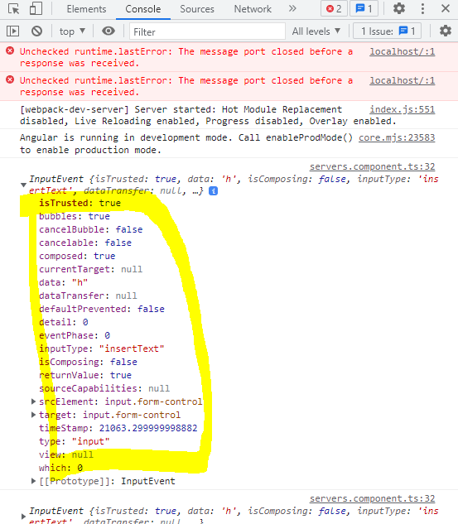

* On the target if we scroll down we can see the value, which is the actual value entered by the user.

* In our typescript code(servers.component.ts), we can set a server name property which is an empty string by default.

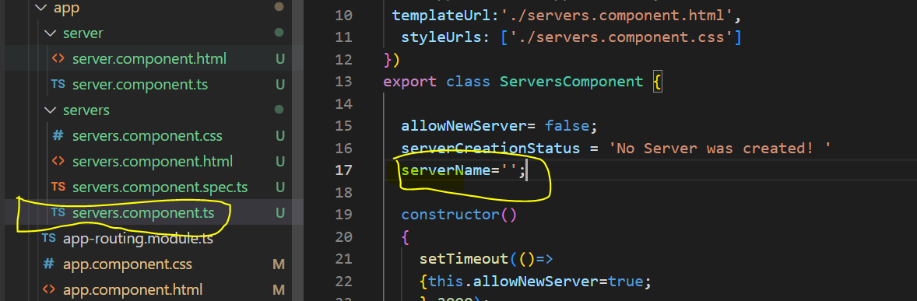

* In onUpdateServerName() , we can update server name from event.target.value

Eg:

  onUpdateServerName(event: Event)

  {

 this.serverName = (<HTMLInputElement>event.target).value;

  }

* Here we need to cast it to HTMLInputElement to get the value , this is needed to inform typescript : that we know that the type of the HTML element of this event will be an HTML input element.
* Now in the HTML file(servers.component.html) file, we can output the value of the servername entered in input , using String interpolation

Eg:

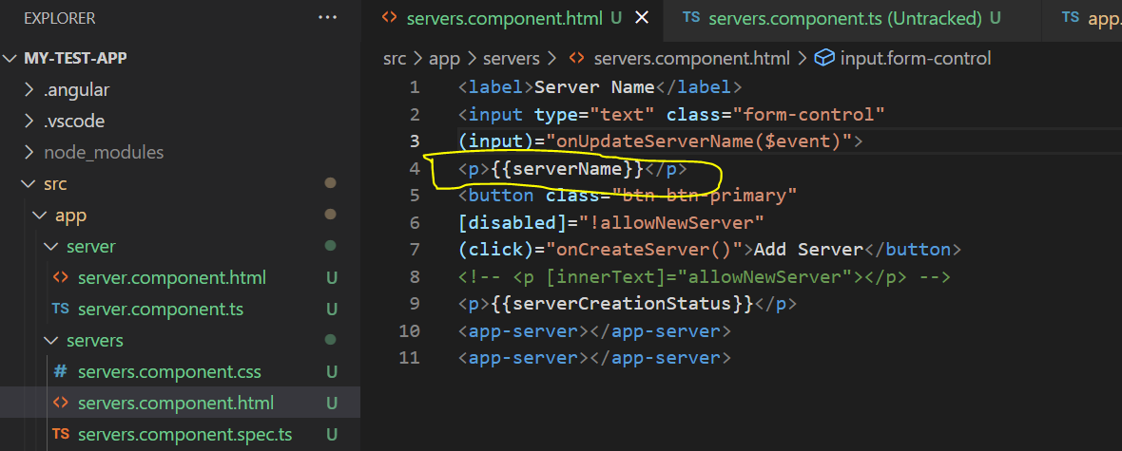

* Since the serverName value is updated in onUpdateServerName, we will get the input value displayed below: